Creating python file
Perform the following tasks after installing PyCharm on your computer.
1. Run the PyCharm from your computer by type PyCharm in the search area in Windows, then click on PyCharm icon. The following window displays. Click Create New Project to create a Python project.

2. Type in the path in Location, the name of the project you want (e.g. Validators), then click Create.

3. In the next page, in left pane of Projects, you see that the project Validators is created. Right click on it, select New then from the submenu select Python File.

4. In the next page, select Python file in the little window and type the name of the python file you want (e.g. ageValidator), then hit Enter.

5. You see that ageValidator file is shown on the project left pane in PyCharm. Now, you can start writing your code in the code area as shown in the figure.

6. The figure below shows a complete code that validates the age. Press CTRL +S to save the file.

7. Right click on the ageValidator in the project pane, then from the menu select Run ‘ageValidator’.

8. Python console displays at the bottom part of PyCharm. It shows the program output or an error (if any). In our example, the program asks the user to enter your age.
Console
9. Go to the console and enter age (e.g. -9). See the output

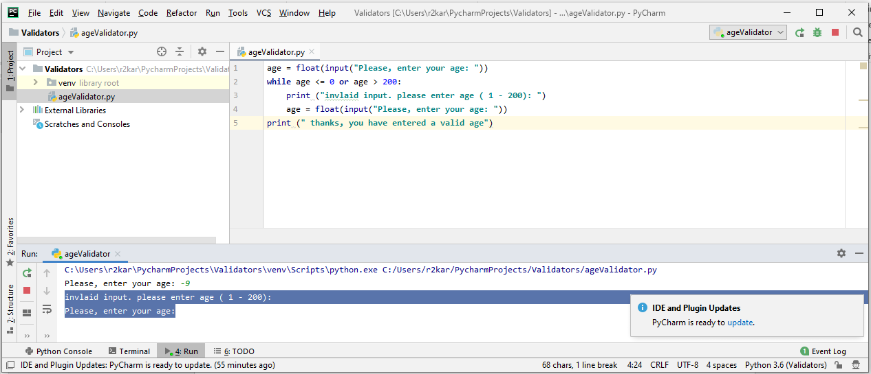
invlaid input. please enter age ( 1 - 200):
Please, enter your age:
You can enter again (e.g. 34). See the output
Please, enter your age: 34
thanks, you have entered a valid age

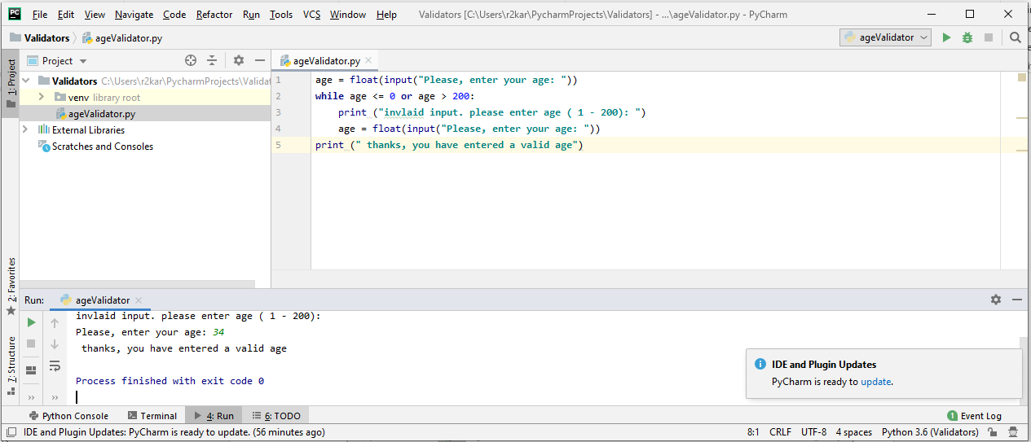

10. How to find and submit your python file to eCentennial

